***Tool & Supply List for Quilt NE Tea Time Placemat Class***

Connie will supply each quilter with a pattern from Quiltworx for a $20.00 fee. She will send the pattern to them, via US Mail, so that they can prepare for class.

Below are the fabric requirements for the pattern. To view color samples of this pattern go to [www.quiltworx.com](http://www.quiltworx.com) and click on the Tea Time Placemat pattern, and view the gallery on the lower left hand side of the page, or search on the Quiltworx Support Network on Facebook. You can also do a search on Pinterest or Instagram.

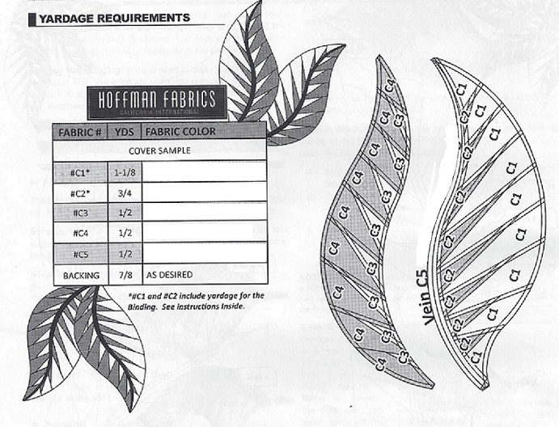

Below are the Tools and Supply List that will be needed to prepare for class and class supplies:

12” Add a Quarter Ruler

6 X 24, 3 X 12 or 18 inch Ruler

Small Scissors

Rotary Cutter & Med. Cutting Matt

Seam Ripper

1 Gal. or 2 Gal. Zip Lock Plastic Bags

Sewing Machine good working order

Size 10 or 12 Machine Needles

High Quality Fine Cotton Thread

Power Strip or Extension Cord

Glue Stick Pen (Sew Line, Fons & Porter)

Large Plastic Covered Paper Clips

Binder Clips (Medium or Large)

Flower Pins

3” X 12” Template Plastic

Purple Thang or Stiletto

(Optional)

Matte Finish Removable Scotch Tape