Bradley and Judy Niemeyer designed the layout and foundation pieces for Seasonal Table Runners. A collection of fabrics designed by Hoffman Fabrics were used to make the samples shown on the cover. A sewing technique called foundation paper piecing is used when sewing the pieces onto the foundation units. Curved piecing and traditional piecing are required to join and finish the quilt after the foundation piecing is completed.

[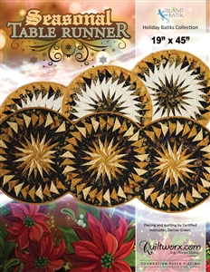](http://store.quiltworx.com/product-p/jnq54p.htm)